Date: 20.11.2020
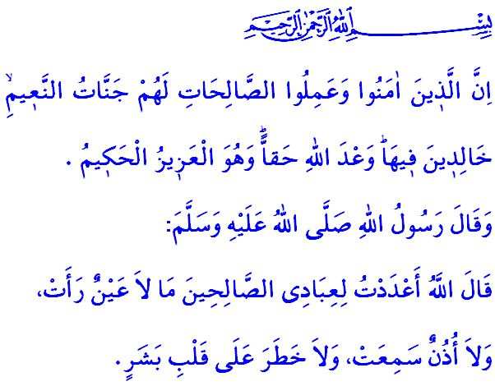
HEAVEN: AN ENDLESS BLESSING TO WELCOME MUSLIMS
Honorable Muslims!
Allah the Almighty (swt) states in the verse I have recited as follows: “Indeed, those who believe and do righteous deeds - for them are the Gardens of Pleasure. Wherein they abide eternally; [it is] the promise of Allah [which is] truth. And He is the Exalted in Might, the Wise.”
Our Lord, the Owner of Glory, Majesty, Honor, and Perfection, has granted us all a life that starts with coming into this world and extends into the Hereafter. He (swt) has informed us that we will either have the reward or the punishment in the Hereafter, the land of eternity, for the deeds we do in this world that is in effect a testing phase. He (swt) has given the glad tiding of entry into heaven for those who mobilize their mind, heart, skills, wealth, and capabilities to have faith and do righteous and beneficial deeds. But He (swt) also has warned those who deny and turn their back at the truth and spend their lives doing evil about a severe punishment.
Dear Believers!
Heaven, which is embellished with unique blessings, is the land of eternity where peace and serenity prevail always. It is the reward for those servants of Allah (swt) who have spent their lives seeking for His appreciation, performed their worships with ikhlas, and made no concessions on good morals. It is the home of joy and happiness where we will meet our Lord (swt) and our loved ones.
Dear Muslims!
Muslims, who avoid crossing the boundaries set out by Allah (swt), are given their book of deeds from their right hand side upon the Resurrection. The divine sound of “Enter it in peace, safe [and secure]!” echoes. The state of the would-be residents of heaven who have left behind any kind of pain, suffering, illness, and trouble is described in the Holy Qur’an as follows: “When they reach it, its gates will ben opened and its keepers will say: Peace be upon you! You have done well, so come in, to stay forever!” Now there will be neither sorrow nor longing or hardships. The Almighty Allah (swt), Who has welcome His servants with His boundless mercy and bounty, has now granted in full their reward for their efforts in the world.
Dear Believers!
There are vivid descriptions of various heavenly blessings in the Holy Qur’an and in the hadiths that inspire believers for the good. Prophet Muhammad (saw) narrates what our Lord states about those niceties that could not be described enough as follows: “I have prepared some blessings for my righteous servants in heaven that no eye has seen, no ear has heard, and no human has ever dreamed of.”
So, let us continue showing patience and perseverance, doing charitable works and good to reach heaven even if the path to it is a challenging one. Let us strive with faith and hope to enter into heaven with our Lord pleased with us and us pleased with Him (swt).
Dear Muslims!
Just like the whole world, we as a nation also are going through a big fight against the pandemic. It is a duty upon all of us to observe all the measures put in place for our health, in addition to mask-wearing, social distancing and hygiene rules. We kindly ask honorable elder members of our congregation over 65 years of age and our brothers and sisters with chronic health problems, both of whom are in risk groups, to continue performing their prayers at their homes throughout this period. Let us not forget that inshaallah we will come out victorious from this challenging test and be the addressees of rewards as long as we observe the measures taken.

Luqman, 31/-8-9.
Hijr, 15/46.
Zumar 39/73.
Bukhari, Bad’ al-Khalq, 8. General Directorate of Religious Services

